Bassoon Excerpts, West Shore Symphony Orchestra
Four excerpts total: Tchaikovsky (2 spots), Tate, Strauss
Please submit video recording to jswiley@susqu.edu by June 15, 2022
(Doesn’t need to be all one take)

From Tchaikovsky Symphony No. 4
Movement 2:
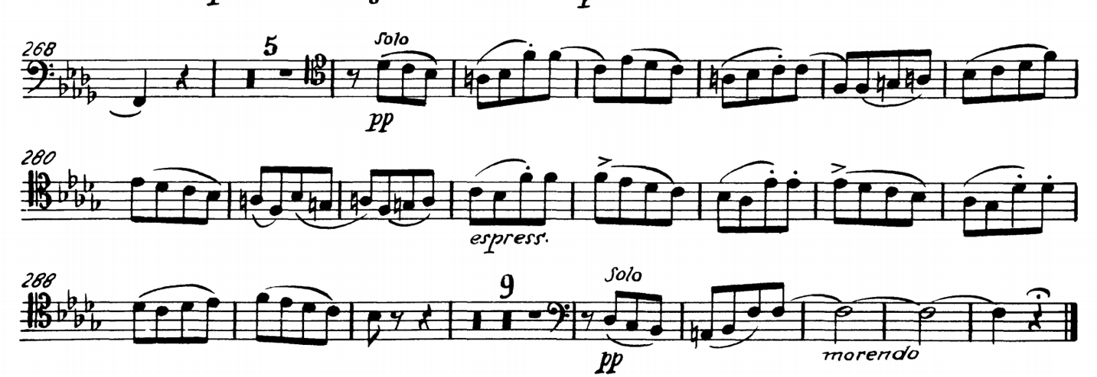
Movement 1:

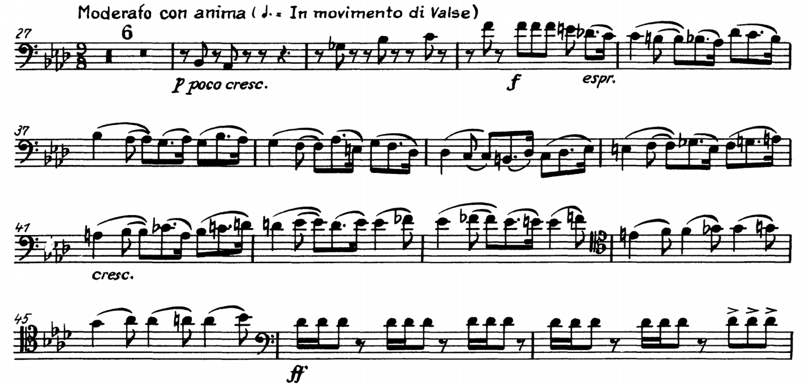

From Jerod Impichchaachaaha’ Tate “The Indian Spirit at Mesa Falls” m. 95-104, dotted half = 56 (Recording found here: https://www.dropbox.com/s/n7gyc1mhpvtw0w8/02%20The%20Indian%20Spirit%20at%20Mesa%20Falls.mp3?dl=0 Excerpt begins at 4:31)

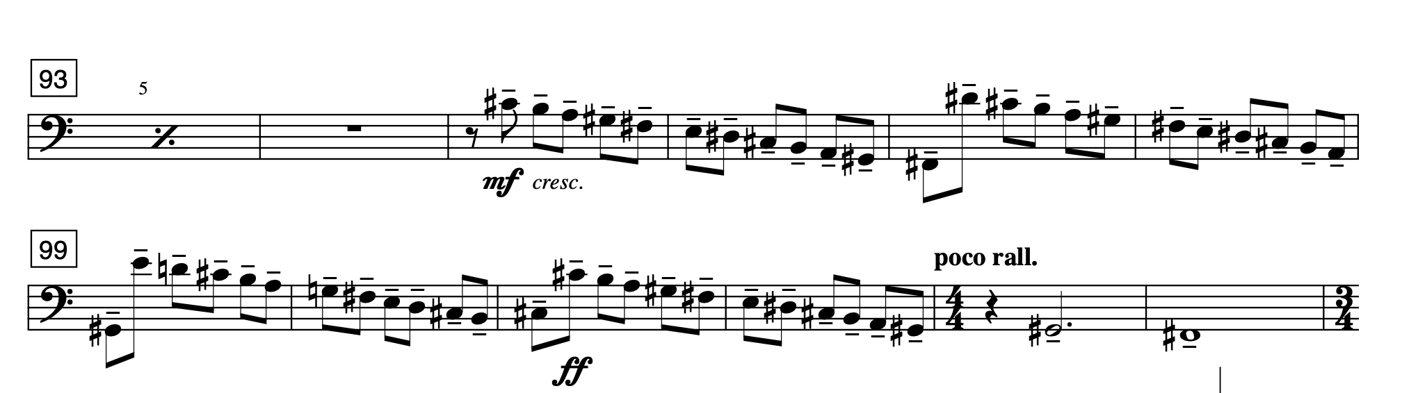

From Richard Strauss, Death and Transfiguration, two excerpts marked below:

